**Test Case 28 – Roof eaves are turned into shading devices automatically**

*Test Description* : A simplified 3-zone model of a building shaped like a residential home has been created. The home is a simple two story example that has a small attic formed by a roof with a 30 degree pitch which slopes along one of the site’s Cartesian axes. This test is a simple test that ensures the authoring tool is able to automatically break the roof into a space bounding object and shade object appropriately without any special user intervention.

The roof is drawn as a set of two continuous planes, which must then be broken into separate planes automatically and assigned the proper surfaceTypeEnum in gbXML.

The model is simple to create and tests a reasonably simply outcome.

*Space Names:* This is important because the gbXML validator requires the strings in the test file match the standard file. The name check is case sensitive. Ensure that the id attribute of the Space elements in the gbXML test file match the standard file space names shown below.

|  |  |  |
| --- | --- | --- |
| Standard File Space Name | Test File Space Name | Verified |
| sp-1-Space |  |  |
| sp-2-Space |  |  |
| sp-3-Space |  |  |

*Special Considerations:*

1. There are 2 triangular walls in this test file.
2. The sloping roof objects and shades have azimuths of 90 and 270 degrees, and it is expected that these objects will match the tilts and azimuths presented in this example document.

*Complexity of the BIM Model:*

1. Simple planar surfaces orthogonal to the project Cartesian reference frame.
2. Simplified walls with no visible layers.
3. Simple details at interfaces of surfaces.

*Description of Test:*

Figure 1 shows a simple 3D axonometric view of how the example is massed. In this case, the figure shows a basement (Space 1) separated from the space above grade (Space 2). The underground walls in space 1 are partially stubbed out above grade. Figure 2 provides a section view schematic, looking north, that shows the heights of the enclosed spaces, the thickness of floors in the model and the pitch of the roof. It also shows the dimensions necessary to compute the basic geometry of the overhang.

Figure 3 that shows the dimensions of Space 1 (the basement) along with the wall thickness (8”). North is assumed to be the top of the page. In case the dimensions are difficult to read, they are: 50’10” (north-south) x 45’6” (east-west).

Figure 4 finally shows another section view, this time looking east, to show that the roof overhang does not project over the north or south sides of the enclosed spaces.

Roof

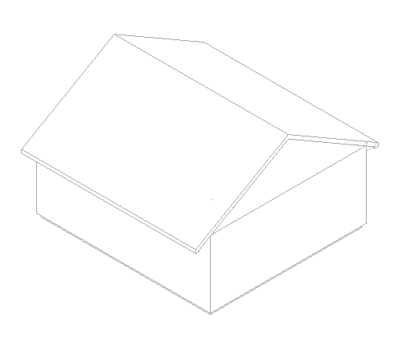

Overhang

Triangular Wall

**N**

su-7

Figure 1: Test case 5 shown in an axonometric cutaway view to reveal the qualitative relationship between the different surfaces and spaces.

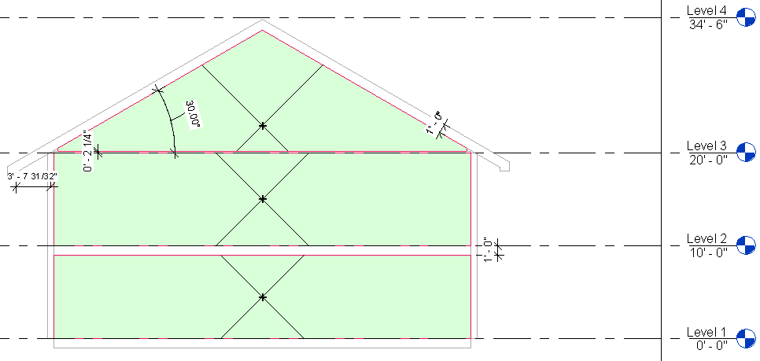

Space 3

Space 2

Space 1

Figure 2: Section looking north that details the height of a space, the construction thicknesses of the floors, ceilings, and roof, as well as the dimensions of the roof and overhang.

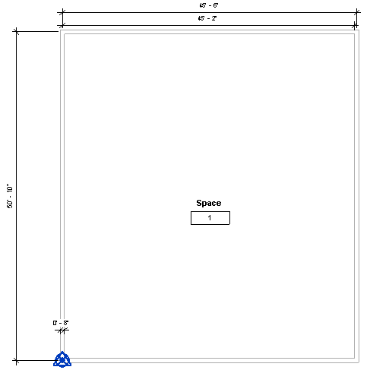

Figure 3: Space 1, located on the first floor. The dimensions (50’10” x 45’6” centerline to centerline) shown here in plan view, are identical for each space. The wall thickness (8”) is also the same for all three spaces. This means that the area for each space will be identical, although the volume will not because of geometric differences between the spaces’ heights and roof/ceiling configurations.

Roof

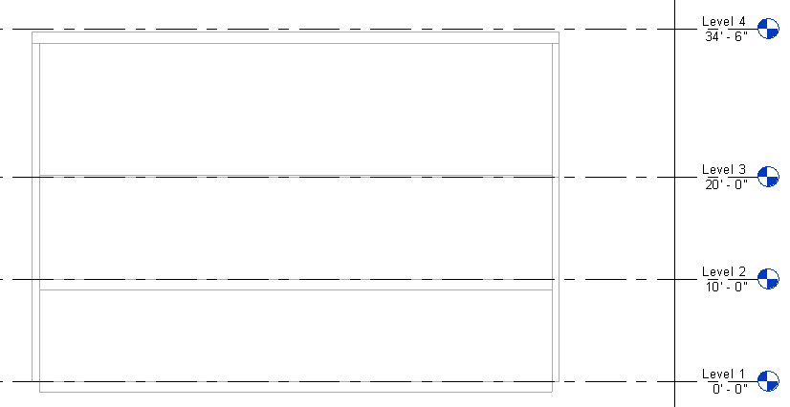

Space 3

Space 2

Space 1

Figure 4: Section cut of the file, looking east. This section is cut to highlight the fact that the roof does not form overhangs on the north or south side of the project.

|  |  |  |  |
| --- | --- | --- | --- |
| Surface Description | Surface Thickness | Surface Type | Comments |
| Exterior Wall | 8” | n/a |  |
| Roof | 12” | n/a |  |
| Floor Slab | 12” | n/a |  |
| Attic Ceiling | 2’1/4” | n/a |  |

Table 1: Dimensions and descriptions of wall elements in Test Case 1.

*Example of the gbXML Code Relevant to this Example*

Below is the example gbXML for the roof surfaces in Space 3 and for the shade that is created from the portion that extends beyond the edge of the enclosed space.

<Space id=”sp-Space-3” …>

…

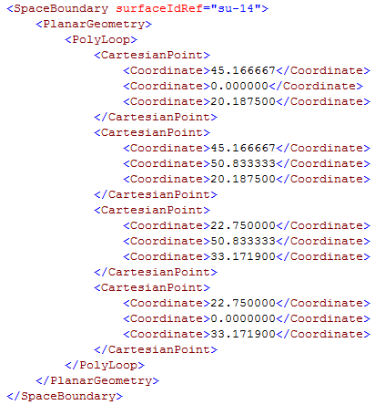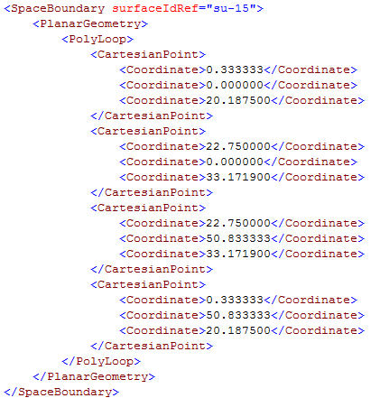

</Space>

Code Snippet 1: SurfaceBoundary representations for the sloping roof. Shell geometry PolyLoop elements are identical since this is a roof element, so they have been omitted from the example

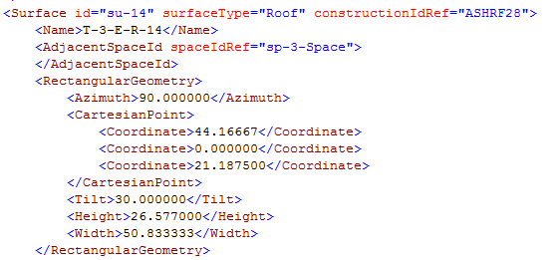

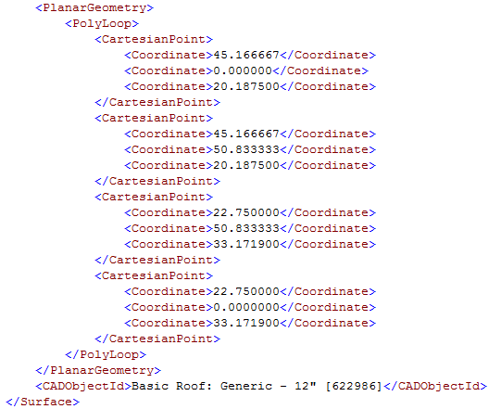

Code Snippet 2: Surface definition for one of the Roof elements.

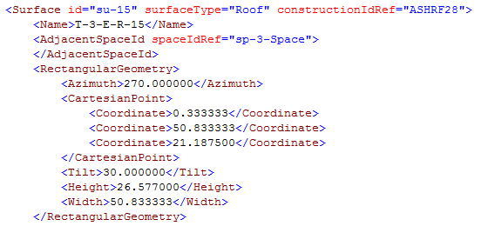

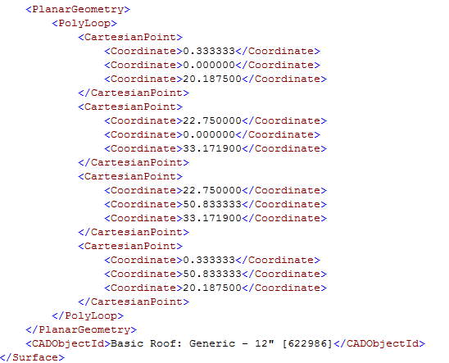

Code Snippet 3: Surface definition for one of the roof elements.

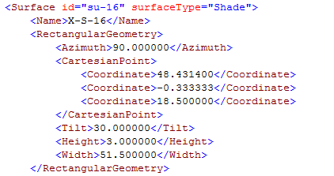

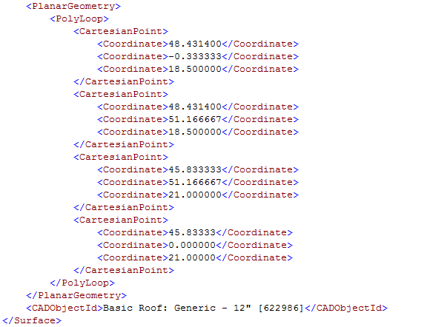

Code Snippet 4: Code snippet for one of the shades that is formed when the roof is split into a roof and shade element.

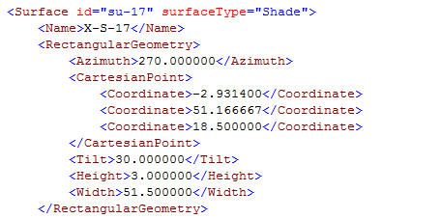

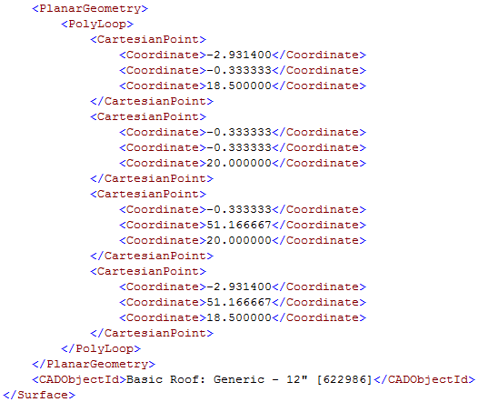

Code Snippet 5: Code snippet for one of the shades that is formed when the roof is split into a roof and shade element.